VENUE, COUNTRY

supplementary regulations

Date: restaging date:

ORGANISER
IMN | 506/XX |  | FMN
Organ. club |  |  | Address
Contact |  |  | Email
Track name |  |  | Licence n°
Track size | Length: Width of straight: Width of bends:
MEETING TIME SCHEDULE
Pits open
Signing on
Machine examination
Track inspection
Track walk
Autograph session compulsory for riders selected by the FIM
1st international jury meeting
Practice
Riders briefing
Parade
1st heat
Prize-giving ceremony |  | Straight after the last heat
Final international jury meeting |  | 30min after the last heat
Payment of prize money |  | By bank transfer within 72 hours after the final jury meeting
Leaving the meeting: No rider may leave the pits, and no machine or engine shall be removed from there, until 30 minutes after the conclusion of the last race of the meeting, and then only with the permission of the race director.

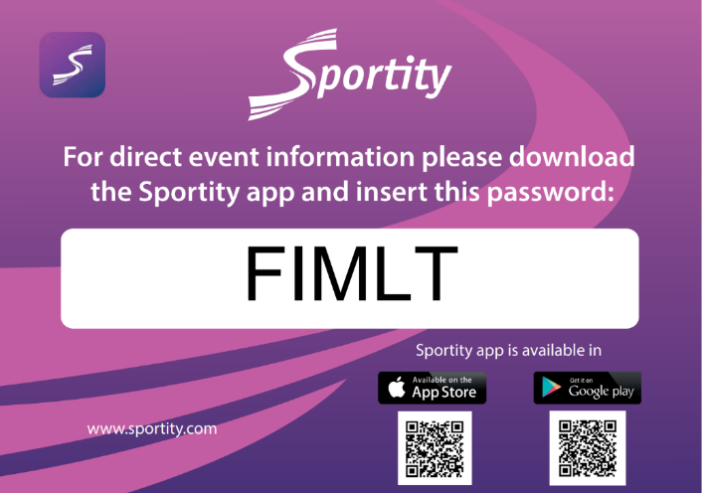

OFFICIALS
FIM jury president
FIM referee
FMNR delegate
FIM race director
FIM CCP coordinator
FIM jury secretary
Clerk of the course
Technical steward
Chief medical officer/doctor
Environmental steward
PROTESTS AND APPEAL
Any neutral or legal person, holder of a FIM licence, who considers to be directly prejudiced, during a meeting sanctioned by the FIM, following dangerous, unsporting or fraudulent behaviour, riding act, which has not been subject to a decision by the disciplinary bodies listed in art. 3 of the FIM disciplinary code has the right to protest against such behaviour, riding or act. Any neutral or legal person, holder of a FIM licence and directly affected by a decision taken during a meeting under the authority of the FIM has the right to lodge an appeal against such a decision. This appeal must be presented to the CAI 5 days at the latest after the notification of that decision. Appeals against a disciplinary decision taken by the international jury will be dealt with by the CAI. Protests against the eligibility of a rider, passenger, team or a motorcycle entered, must be made before the start of the official practice. Protests against results must be presented to the international jury within 30 minutes following the last race. All protests to the international jury must be made in accordance with the requirement of the disciplinary and arbitration code of the FIM and be accompanied by a fee of 660€ or equivalent amount in local currency exchange rate of the day of the protest (ref. https://www1.oanda.com/currency/converter) returnable if the protest is justified or forfeited if the disciplinary body considers the protest to be groundless, or if it is withdrawn without a hearing. An appeal may be made against a decision of the international jury to the international court of appeal (CAI).
ENVIRONMENTAL MAP

