supplementary regulations

FIM sidecarCROSS WORLD CHAMPIONSHIPS

The Moto Club
The National Federation (FMNR)
will organise a round of the 2025 FIM SidecarCross World Championship. The event will be held in accordance with the FIM Sporting Code together with the relevant Appendices and Regulations.

The event will be held in Venue + Country

Date of the event IMN 204/

ACCESS See attached map of access

Nearest airport
Motorway Exit
National Road
Nearest town at km

ORGANISER

Name (Club)
Address
Tel. No Email
Website

CIRCUIT See attached drawing of the circuit

Name
Length Minimum Width
Google map link

NEAREST HOSPITAL

Name
Address
Tel. No Email
Website
Google Map link

SECRETARIAT OF THE EVENT

Address
Tel. No Email

Opening days / hours

Thursday from to
Friday from to
Saturday from to
Sunday from to

TECHNICAL CONTROL OF THE EVENT

Date from to Place

1. ENTRIES

Entries must be made online via APO Multimedia’s Registration Platform.

For any info, please contact APO Multimedia: sportoffice@fimsidecarcross.com

Closing date of entries: 15 days before the start of the event.

2. INSURANCE

By endorsing the application form for entry, the FMN of the rider certifies that the rider is insured in accordance with the FIM requirements.

The organiser has contracted a third party insurance in accordance with Art. 110.1.2 of the FIM Sporting Code.

The general liability insurance coverage which shall not be less than the minimum standards provided for by the national laws of the country in which the relevant event is taking place.

This insurance includes a guarantee of amount in Euros or equivalent in local currency.

The organiser disclaims all responsibility for damage to a motorcycle, its accessories and components arising out of an accident, fire or other incident.

3. PROTESTS AND APPEALS

Any person or group of persons (rider, entrant, manufacturer, official, etc.), recognised by the FIM and concerned by a decision taken under the authority of the FIM, may ask for redress for the consequences of that decision.

Protests may be lodged to the Race Direction according to the FIM Disciplinary Code and be accompanied by applicable deposit of € 660.-*, returnable if the protest is justified.

An appeal against the decision of the Race Direction may be lodged to the FIM Stewards Panel. This appeal must be presented 30 minutes at the latest after the notification of that decision and must be accompanied by a deposit of € 1’320.-*, returnable if the appeal is justified.

An appeal against the decision of the FIM Stewards Panel may be lodged to the CAI. This appeal must be presented 5 days at the latest after the notification of the FIM Stewards Panel's decision (Security deposit for appeal: € 1’320.-*).

Generally, protests against the eligibility of a rider, entrant or a motorcycle entered, must be made before the start of the official practice.

Any other protests must be lodged immediately after the reason for the protest is known.

Protests against results must be presented to the Race Direction within 30 minutes following the announcement of the results.

If the protest entails dismantling a motorcycle, the protest fee must be accompanied by an additional deposit of € 120.-*. This fee must be paid by the losing party to the mechanic of the rider who had to open the engine.

Protests entailing a fuel control must be accompanied by an additional deposit of € 800.-*.

*or the equivalent amount in local currency

4. FUEL

In accordance with FIM specifications. See the FIM Fuel Regulation of the current year.

5. TIMETABLE

See attached timetable.

6. TRAVEL INDEMNITIES AND PRIZES

All amounts are shown in Euro (€). They are net amounts from which no deductions are allowed. They are payable in Euro (€) only (cash payments, please do not use bank notes over 50 Euros).

Minimum prize scale / Barème minimum des prix
Position € Position €
1. 300.- 11. 60.-
2. 250.- 12. 50.-
3. 200.- 13. 50.-
4. 160.- 14. 50.-
5. 130.- 15. 50.-
6. 110.- 16. 50.-
7. 100.- 17. 50.-
8. 90.- 18. 50.-
9. 80.- 19. 50.-
10. 70.- 20. 50.-

A travel indemnity will be paid to the sidecar teams by the Organiser. All the teams which qualified on Saturday to participate in the FIM SidecarCross World Championship Races, as well as the first two reserve sidecar teams who are allowed to take part in the warm-up on Sunday, will receive a travel indemnity of € 500.-.

Venue of the Payment: at

7. PRIZE-GIVING CEREMONY

The first three riders in each FIM SidecarCross World Championship (overall standings) must take part in the official Prize-Giving Ceremony, which must be held immediately after the last Race of the meeting.

The riders concerned must attend the prize-giving ceremony until the end. Any infraction of this rule will be penalised by the Race Direction.

8. OFFICIALS

FIM Representative
(if applicable)
Race Direction |  | Licence | Email
FIM Delegate
FIM Race Director | Dave Edwards | 50183 | dave3902@icloud.com
Clerk of the Course
Stewards Panel |  | Licence | Email
FIM Chief Steward
FMNR Steward
Technical |  | Licence | Email
FIM Technical Director | Allan Laurimäe | 15642 | allan.laurimae@gmail.com
FMNR Chief Technical Steward
FMNR Technical Steward
Medical |  | Licence | Email
Chief Medical Officer
Sustainability |  | Licence | Email
FIM Sustainability Representative (if applicable)
FMNR Sustainability Steward
Other Officials |  | Licence | Email
FIM Chief Flag Steward | Kenny Gardner | 50189 | kgracing14@gmail.com
Chief Timekeeper
Promoter Representative | APO Multimedia / Martin Bena |  | martin.bena@ fimsidecarcross.com
Official Responsible of Protocol | Nikola Neterderova |  | nikola@fimsidecarcross.com
Press Officer APO Multimedia | Nikola Neterderova |  | nikola@fimsidecarcross.com
Press Officer
Paddock Official
Secretary of the Race Direction

No SR`s can be approved with a TBA note for the following roles: Clerk of the Course, FMNR Steward, FMNR Chief Technical Steward, Chief Medical Officer.

The event will be organised in conformity with the FIM Sporting Code, the CMS Regulations, the general rules of the FMNR, when applicable and these Supplementary Regulations which have been duly examined and approved by the FMNR.

9. INTERPRETATION OF THE SR

The interpretation of these Supplementary Regulations rests entirely with the Race Direction.

Place and date:

The Clerk of the Course:

Approved by FMNR:
The Championship Promoter / FIM will publish in due time the complete or updated timetable of the event on the dedicated FIM SidecarCross World Championship Sportity Channel.

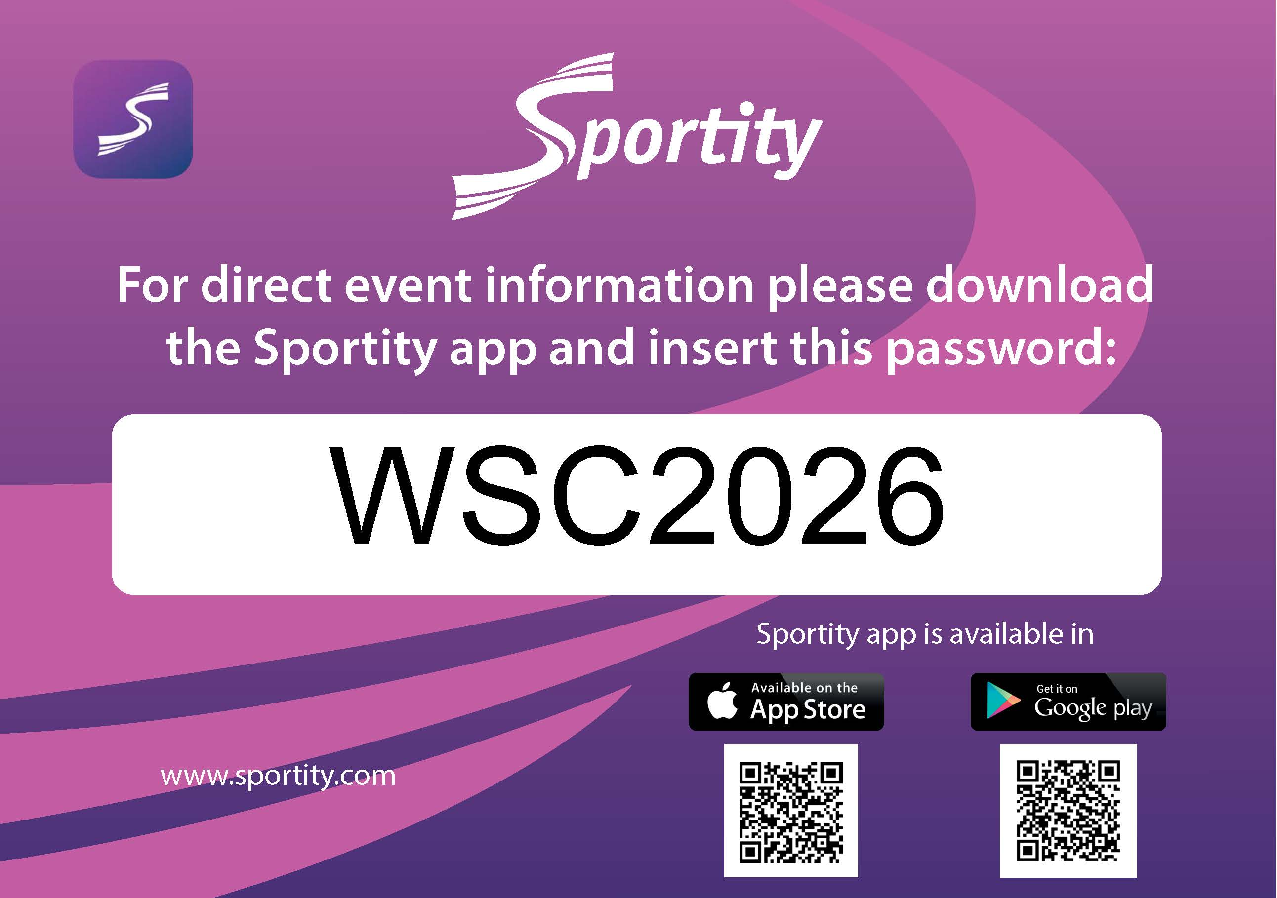

TIMETABLE FOR

FIM SIDECARCROSS WORLD CHAMPIONSHIP

WITH SUPPORT RACES

FRIDAY
Briefing of the Technical Stewards: | 16:00
Sidecars / Technical control and verification: | 17:00 – 19:00
1st circuit control: | 15:00
Meeting with the organisers : | 17:00
2nd circuit control (if necessary): | 18:00

The Championship Promoter / FIM will publish in due time the complete or updated timetable of the event on the dedicated FIM SidecarCross World Championship Sportity Channel.

TIMETABLE FOR
FIM SIDECARCROSS WORLD CHAMPIONSHIP
WITH QUADS

FRIDAY
Briefing of the Technical Stewards: | 14:00
Sidecars + Quads/Technical control and verification: | 15:00 – 19:00
1st circuit control: | 15:00
Meeting with the organizers: | 17:00
2nd circuit control (if necessary): | 18:00

GOOGLE MAP LINKS

Paddock
Welcome Office
Opening Ceremony
Other

HOTELS SUGGESTIONS

(1st choice)
Hotel Name
Address
Tel. No
Email
Website

(2nd choice)
Hotel Name
Address
Tel. No
Email
Website

(3rd choice)
Hotel Name
Address
Tel. No
Email
Website

Please insert hereafter or send by mail with the SR for approval:

- Your FMNR logo
- The Organiser’s Logo
- The drawing of the circuit
- The access map

